DAO – Data access object

Step 1

Java connectivity (JDBC)

MySQL connector

structure

- java file entity

-dao

1) in - CRUD declaration

2) class - business logic

- helper - db connect configuration

- main

Step 2

**Mysql workbench**

CREATE DATABASE itvlab;

use itvlab;

create table User(

userId int auto_increment primary key,

username varchar(30) not null unique,

password varchar(10) not null,

role varchar(20) not null

);

create table Patient (

patientId int auto_increment primary key,

firstname varchar(30) not null ,

lastname varchar(40),

dateofbirth date,

contactNumber varchar(15),

address varchar(20)

);

create table Appointment(

appointmentId int auto_increment primary key,

patientId int,

userid int,

appointmentDate date not null,

appointmentTime Time not null,

testType varchar(50) not null,

foreign key(patientId) references Patient(patientId),

foreign key(userId)references User(userId)

);

Step 3

New – new maven project – next

Catalog – internal- next

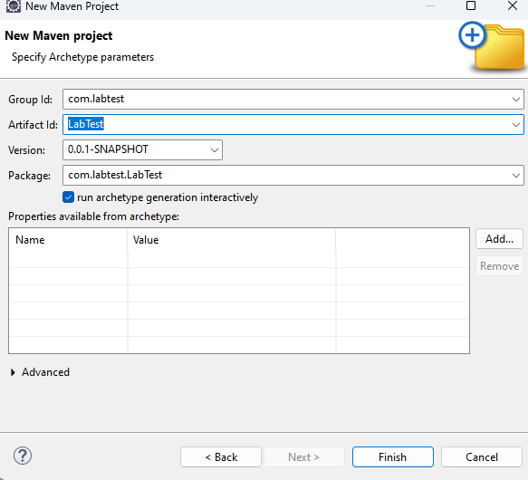

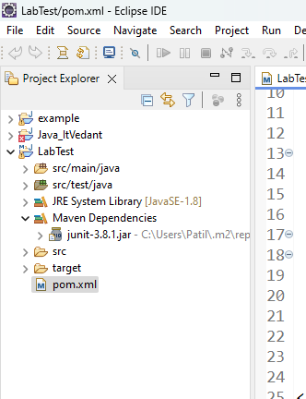

**Step 4**

Select mysql connector version from

<https://mvnrepository.com/artifact/mysql/mysql-connector-java>

**step 5**

poml .yml add inside <dependencies> tag

<!-- https://mvnrepository.com/artifact/mysql/mysql-connector-java -->

<dependency>

<groupId>mysql</groupId>

<artifactId>mysql-connector-java</artifactId>

<version>8.0.33</version>

</dependency>

Step 6

Create packages – structure

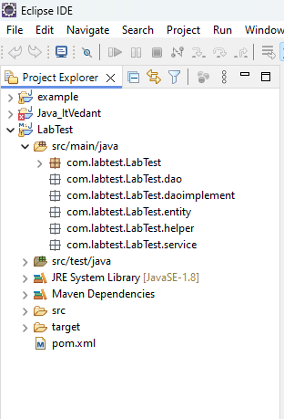

**Step 7 create three (3) entity inside entity package**

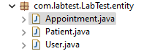

**Step 8 dao It is an interface**

Create inside dao package

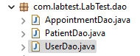

Step 9 create 3 class inside daoimplement package

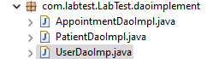

Step 10 inside helper package create



Step 11 inside service package create



Step 12 structure of project

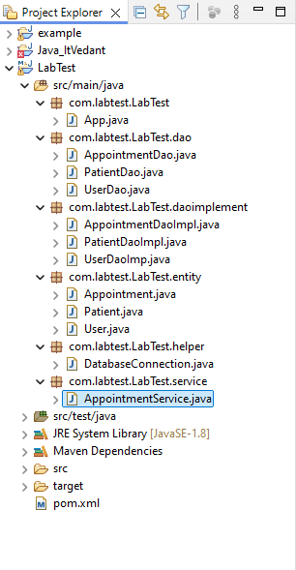

Insert data into mysql

